Name: Priyangan Vasantharajan
STUDENT_ID : 25197298
Program Creation Idea
Hospital Management System

Python

Class Overview & Structure
Super Class
Hospital

Sub Class
Doctors
Sub Class
Patients
Sub Class
Appointments

Main File with Menu
Appointment_doc.py
Doctor_doc.py
Main_doc.py
Patient_doc.py
Sub classes’ Files
OOP - Structure

1.Instroduction about my HMS:
This is a software which is used to manage doctors, patients, appointment details through the Internet. It helps to reduce manual works in the hospital management department. Moreover, we can save and use the hospital related data easily in the daily purposes.

2.Problem & solution with our creation:
Manual records and processing are very slow and not secure and also more spaces need to be saved the data that’s why this software helps to improve features and reduce those problems.
Persons who are working in the hospital management system and other patients also can track easily and connect quickly with hospital. Hopefully, this is the most important for hospital development.

3.Special / Key Features:
We can manage
- Add_patient
- View_patient
- Add_doctor
- View_doctor
- Book_appointment
- cancel_appointment
- view_all_appointments

4.Program Design
- Input user’s data
- Data processed by the program
- Data save
- Output Information

5.Used Data Structures in this Software (Python)
1.Functions
2.Multiple Files
3.Dictionary / List
4.Import Method
5.main()
6.File Handling
7.Error Exception
8.OOP

6.Test Case’s Examples:

7. Program’s Flow chart
This is my Program’s direct idea and main purpose for my users who are using HMS.
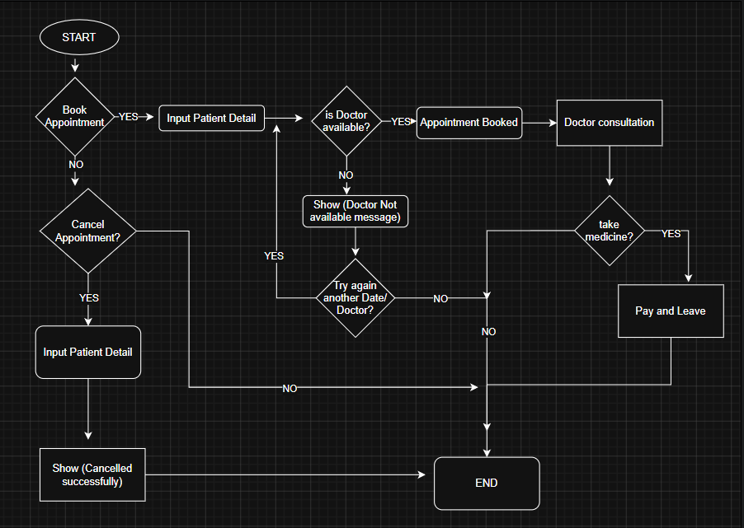

WWW.drawio.com
https://drive.google.com/file/d/1iv3ZjZ1A2Bo_A2AmxSW7EcLnObZW_sXy/view?usp=sharing

8.Conclusion:
We can do our management works faster and easy. Hopefully, this software will be improved in future. So This is very important and useful application for us.

